https://en.wikipedia.org/wiki/Pay-per-click:
Pay-per-click
From Wikipedia, the free encyclopedia
Pay-per-click (PPC), also known as cost per click (CPC), is an internet advertising model used to direct traffic to websites, in which an advertiser pays a publisher (typically a website owner or a network of websites) when the ad is clicked.
Pay-per-click is commonly associated with first-tier search engines (such as Google AdWords and Microsoft Bing Ads). With search engines, advertisers typically bid on keyword phrases relevant to their target market. In contrast, content sites commonly charge a fixed price per click rather than use a bidding system. PPC "display" advertisements, also known as "banner" ads, are shown on web sites with related content that have agreed to show ads and are typically not pay-per-click advertising. Social networks such as Facebook and Twitter have also adopted pay-per-click as one of their advertising models.
However, websites can offer PPC ads. Websites that utilize PPC ads will display an advertisement when a keyword query matches an advertiser's keyword list, or when a content site displays relevant content. Such advertisements are called sponsored links or sponsored ads, and appear adjacent to, above, or beneath organic results on search engine results pages, or anywhere a web developer chooses on a content site.^{[1]}
The PPC advertising model is open to abuse through click fraud,^{[2]} although Google and others have implemented automated systems^{[3]} to guard against abusive clicks by competitors or corrupt web developers.^{[4]}

Purpose
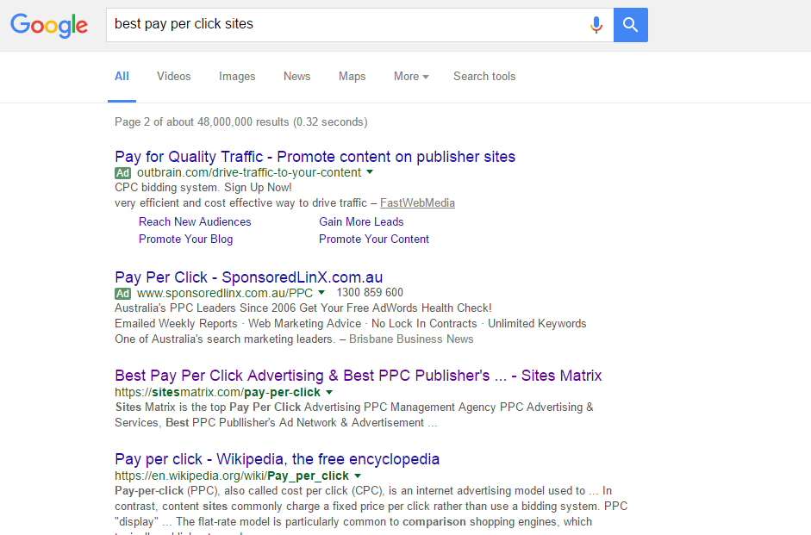
Pay per click advertising
Pay-per-click, along with cost per impression and cost per order, are used to assess the cost effectiveness and profitability of internet marketing. Pay-per-click has an advantage over cost per impression in that it tells us something about how effective the advertising was. Clicks are a way to measure attention and interest. If the main purpose of an ad is to generate a click, or more specifically drive traffic to a destination, then pay-per-click is the preferred metric. Once a certain number of web impressions are achieved, the quality and placement of the advertisement will affect click through rates and the resulting pay-per-click.

Construction
Pay-per-click is calculated by dividing the advertising cost by the number of clicks generated by an advertisement. The basic formula is:
Pay-per-click ($) = Advertising cost ($) ÷ Ads clicked (#)
There are two primary models for determining pay-per-click: flat-rate and bid-based. In both cases, the advertiser must consider the potential value of a click from a given source. This value is based on the type of individual the advertiser is expecting to receive as a visitor to his or her website, and what the advertiser can gain from that visit, usually revenue, both in the short term as well as in the long term. As with other forms of advertising targeting is key, and factors that often play into PPC campaigns include the target's interest (often defined by a search term they have entered into a search engine, or the content of a page that they are browsing), intent (e.g., to purchase or not), location (for geo targeting), and the day and time that they are browsing.

Flat-rate PPC
In the flat-rate model, the advertiser and publisher agree upon a fixed amount that will be paid for each click. In many cases the publisher has a rate card that lists the pay-per-click (PPC) within different areas of their website or network. These various amounts are often related to the content on pages, with content that generally attracts more valuable visitors having a higher PPC than content that attracts less valuable visitors. However, in many cases advertisers can negotiate lower rates, especially when committing to a long-term or high-value contract.
The flat-rate model is particularly common to comparison shopping engines, which typically publish rate cards.^{[5]} However, these rates are sometimes minimal, and advertisers can pay more for greater visibility. These sites are usually neatly compartmentalized into product or service categories, allowing a high degree of targeting by advertisers. In many cases, the entire core content of these sites is paid ads.

Bid-based PPC
The advertiser signs a contract that allows them to compete against other advertisers in a private auction hosted by a publisher or, more commonly, an advertising network. Each advertiser informs the host of the maximum amount that he or she is willing to pay for a given ad spot (often based on a keyword), usually using online tools to do so. The auction plays out in an automated fashion every time a visitor triggers the ad spot.
When the ad spot is part of a search engine results page (SERP), the automated auction takes place whenever a search for the keyword that is being bid upon occurs. All bids for the keyword that target the searcher's Geo-location, the day and time of the search, etc. are then compared and the winner determined. In situations where there are multiple ad spots, a common occurrence on SERPs, there can be multiple winners whose positions on the page are influenced by the amount each has bid. The bid and Quality Score are used to give each advertiser's advert an ad rank. The ad with the highest ad rank shows up first. The predominant three match types for both Google and Bing are broad, exact and phrase match. Google also offers the broad modifier match type which differs from broad match in that the keyword must contain the actual keyword terms in any order and doesn't include relevant variations of the terms.^{[6]}
In addition to ad spots on SERPs, the major advertising networks allow for contextual ads to be placed on the properties of 3rd-parties with whom they have partnered. These publishers sign up to host ads on behalf of the network. In return, they receive a portion of the ad revenue that the network generates, which can be anywhere from 50% to over 80% of the gross revenue paid by advertisers. These properties are often referred to as a content network and the ads on them as contextual ads because the ad spots are associated with keywords based on the context of the page on which they are found. In general, ads on content networks have a much lower click-through rate (CTR) and conversion rate (CR) than ads found on SERPs and consequently are less highly valued. Content network properties can include websites, newsletters, and e-mails.^{[7]}
Advertisers pay for each single click they receive, with the actual amount paid based on the amount of bid. It is common practice amongst auction hosts to charge a winning bidder just slightly more (e.g. one penny) than the next highest bidder or the actual amount bid, whichever is lower.^{[8]} This avoids situations where bidders are constantly adjusting their bids by very small amounts to see if they can still win the auction while paying just a little bit less per click.
To maximize success and achieve scale, automated bid management systems can be deployed. These systems can be used directly by the advertiser, though they are more commonly used by advertising agencies that offer PPC bid management as a service. These tools generally allow for bid management at scale, with thousands or even millions of PPC bids controlled by a highly automated system. The system generally sets each bid based on the goal that has been set for it, such as maximize profit, maximize traffic, get the very targeted customer at break even, and so forth. The system is usually tied into the advertiser's website and fed the results of each click, which then allows it to set bids. The effectiveness of these systems is directly related to the quality and quantity of the performance data that they have to work with — low-traffic ads can lead to a scarcity of data problem that renders many bid management tools useless at worst, or inefficient at best.

History
There are several sites that claim to be the first PPC model on the web,^{[9]} with many appearing in the mid-1990s. For example, in 1996, the first known and documented version of a PPC was included in a web directory called Planet Oasis. This was a desktop application featuring links to informational and commercial web sites, and it was developed by Ark Interface II, a division of Packard Bell NEC Computers. The initial reactions from commercial companies to Ark Interface II's "pay-per-visit" model were skeptical, however.^{[10]} By the end of 1997, over 400 major brands were paying between $.005 to $.25 per click plus a placement fee.^{[citation needed]}
In February 1998 Jeffrey Brewer of Goto.com, a 25-employee startup company (later Overture, now part of Yahoo!), presented a pay per click search engine proof-of-concept to the TED conference in California.^{[11]} This presentation and the events that followed created the PPC advertising system. Credit for the concept of the PPC model is generally given to Idealab and Goto.com founder Bill Gross.^{[12]}
Google started search engine advertising in December 1999. It was not until October 2000 that the AdWords system was introduced, allowing advertisers to create text ads for placement on the Google search engine. However, PPC was only introduced in 2002; until then, advertisements were charged at cost-per-thousand impressions or Cost per mille (CPM). Overture has filed a patent infringement lawsuit against Google, saying the rival search service overstepped its bounds with its ad-placement tools.^{[13]}
Although GoTo.com started PPC in 1998, Yahoo! did not start syndicating GoTo.com (later Overture) advertisers until November 2001.^{[14]} Prior to this, Yahoo's primary source of SERPS advertising included contextual IAB advertising units (mainly 468x60 display ads). When the syndication contract with Yahoo! was up for renewal in July 2003, Yahoo! announced intent to acquire Overture for $1.63 billion.^{[15]} Today, companies such as adMarketplace, ValueClick and adknowledge offer PPC services, as an alternative to AdWords and AdCenter.
Among PPC providers, Google AdWords, Microsoft adCenter and Yahoo! Search Marketing had been the three largest network operators, all three operating under a bid-based model.^{[1]} For example, in the year 2014, PPC(Adwords) or online advertising attributed approximately $45 billion USD of the total $66 billion USD of Google's annual revenue^{[16]} In 2010, Yahoo and Microsoft launched their combined effort against Google, and Microsoft's Bing began to be the search engine that Yahoo used to provide its search results.^{[17]} Since they joined forces, their PPC platform was renamed AdCenter. Their combined network of third party sites that allow AdCenter ads to populate banner and text ads on their site is called BingAds.^{[18]}

Legal
In 2012 Google was ruled to have engaged in misleading and deceptive conduct by the Australian Competition and Consumer Commission in possibly the first legal case of its kind. The Commission ruled unanimously that Google was responsible for the content of its sponsored AdWords ads that had shown links to a car sales website CarSales. The Ads had been shown by Google in response to a search for Honda Australia. The ACCC said the ads were deceptive, as they suggested CarSales was connected to the Honda company. The ruling was later overturned when Google appealed to the Australian High Court. Google was found not liable for the misleading advertisements run through AdWords despite the fact that the ads were served up by Google and created using the company’s tools.^{[19]}

See also
- Clickthrough rate
- Digital marketing
- Pay-per-call advertising
- Pay to click
- Search engine marketing

References
  - ^ Jump up to: ª ^{b} "Customers Now", David Szetela, 2009.
  - Jump up ^ Jansen, B. J. (2007) Click fraud . IEEE Computer. 40(7), 85-86.
  - Jump up ^ Shuman Ghosemajumder (March 18, 2008). "Using data to help prevent fraud". Google Blog. Retrieved May 18, 2010.
  - Jump up ^ How Google prevents invalid activity Google AdSense Help Center, Accessed November 17, 2014
  - Jump up ^ Card Shopping.com Merchant Enrollment Shopping.com, Accessed June 12, 2007
  - Jump up ^ "Keyword Matching Options Article: Keyword Matching Options Bing Ads". Google Support. Retrieved 26 January 2013.
  - Jump up ^ Yahoo! Search Marketing (May 18, 2010). "Sponsored Search". Website Traffic Yahoo! Search Marketing (formerly Overture). Retrieved May 18, 2010.
  - Jump up ^ The cost of AdWords Google AdWords Help, Accessed May 18, 2012
  - Jump up ^ Jansen, B. J. and Mullen, T. (2008) Sponsored search: An overview of the concept, history, and technology, International Journal of Electronic Business. 6(2), 114 – 131.
  - Jump up ^ Planet Oasis gives web sites promotion clout, Advertising Age July 8, 1996, retrieved December 5, 2012
  - ^ Overture and Google: Internet Pay Per Click (PPC) Advertising Auctions , London Business School, Accessed June 12, 2007
  - Jump up ^ Jansen, B. J. (2011). Understanding Sponsored Search: Coverage of the Core Elements of Keyword Advertising. Cambridge University Press: Cambridge, UK.
  - Jump up ^ Stefanie Olsen and Gwendolyn Mariano (April 5, 2002). "Overture sues Google over search patent". CNET. Retrieved Jan 28, 2011.
  - Jump up ^ Yahoo! Inc. (2002). "Yahoo! and Overture Extend Pay-for-Performance Search Agreement". Yahoo! Press Release. Retrieved May 18, 2010.
  - Jump up ^ Stefanie Olsen (July 14, 2003). "Yahoo to buy Overture for $1.63 billion". CNET. Retrieved May 18, 2010.
  - Jump up ^ Rosenberg, Eric (5 February 2015). "How Google Makes Money".
  - Jump up ^ Singel, Ryan (18 February 2010). "Yahoo and Microsoft Join Search Forces". Retrieved 26 September 2012.
  - Jump up ^ "Link to Webpronews.com Article: Yahoo And Microsoft Introduce The Yahoo Bing Network, adCenter Becomes Bing Ads". WebProNews. Retrieved 26 September 2012.
  - Jump up ^ "Google Inc vs ACCC". Retrieved 2015-07-02.

External links
V ∙ T ∙ E | Web syndication

Categories: | Compensation methods | Pricing | Internet advertising methods | Internet terminology | Marketing terminology

